Aberdeen City Libraries

Book Group
Collection

Our dedicated Book Group Collection provides access to multiple copies of a range of titles which are regularly reviewed and updated.

Each title indicates a set of 12 copies. Alternative formats from the general collection can be included in a set upon request (subject to availability).

Alternative formats include:
- Large Print
- Audiobook
- Playaway –portable preloaded audio device requiring battery and headphones
- eBook
- eAudiobook

Further information about the titles can be found on the library catalogue: www.aberdeencity.gov.uk/library

The following websites may be of general interest to book groups:
- Reading Groups for Everyone: http://readinggroups.org/
- Love Reading – http://www.lovereading.co.uk/

PICTURES AND TEXT COURTESY OF BERTRAMS LIBRARY SUPPLIERS

ABOULELA, LEILA
The Kindness of Enemies
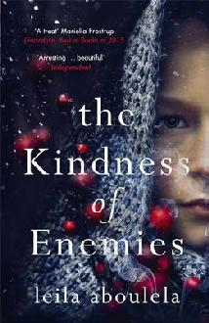
Natasha Wilson, born to a Russian mother and a Muslim father, feels adrift in Scotland and longs for a place which feels like home. Then she meets Oz at the university where she teaches. But when Oz is suspected of radicalism, Natasha's own work and background suddenly come under the spotlight. As suspicions grow around her, Natasha stands to lose the life she has fought to build.

ABOULELA, Leila
Lyrics Alley

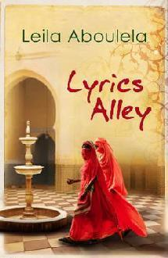
A lyrical and deeply moving novel by a twice Orange-listed rising star, set in pre-Independence Sudan, Egypt and post-war Britain.

ANONYMOUS
Secret Barrister: Stories of the Law and How It's Broken

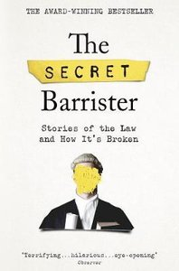
An anonymous barrister offers a shocking, darkly comic and very moving journey through the legal system - and explains how it's failing all of us.

Also available in: CD Audio Book and eBook

ASKEW, CLAIRE
All the Hidden Truths

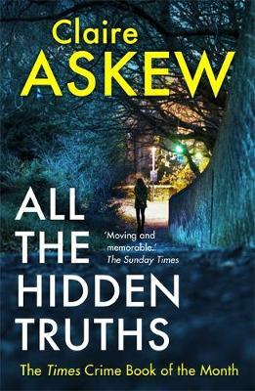
This is a fact: Ryan Summers walked into Three Rivers College and killed twelve women, then himself. But no one can say why. The question is one that cries out to be answered - by Ryan's mother, Moira; by Ishbel, the mother of Abigail, the first victim; and by DI Helen Birch, put in charge of the case on her first day at her new job. But as the tabloids and the media swarm, as the families' secrets come out, as the world searches for someone to blame - the truth seems to vanish.

Also available in: CD Audio Book

ATKINSON, KATE
Life after life
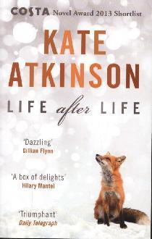During a snowstorm in England in 1910, a baby is born and dies before she can take her first breath. During a snowstorm in England in 1910, the same baby is born and lives to tell the tale. What if you had the chance to live your life again and again, until you finally got it right?
Also available in: CD Audio Book and eBook

Atwood, MARGARET
Oryx and Crake
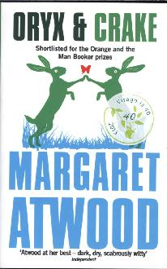Pigs might not fly, but they are strangely altered. So, for that matter, are wolves and raccoons. Jimmy, now calls himself Snowman and lives in a tree, wrapped in an old bed sheet. The voice of Oryx, the woman he loved, teasingly haunts him. The green-eyed children of Crake are his responsibility.

AW, TASH
The Harmony Silk Factory

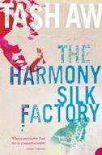
A landmark work of fiction from one of Britain's most exciting new writers: The Harmony Silk Factory is a devastating love story set against the turmoil of mid-twentieth century Malaysia

BACIGALUPI, PAOLO
The Windup Girl

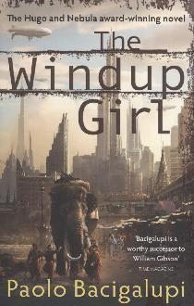The winner of five major Science Fiction awards, The Windup Girl is both a heart-stopping dystopian thriller and a razor-sharp vision of our near future.

BACKMAN, FREDRICK
A Man Called Ove
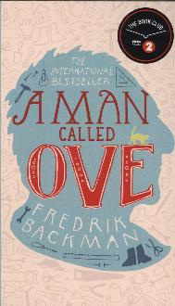
At first sight, Ove is almost certainly the grumpiest man you will ever meet. He thinks himself surrounded by idiots - neighbours who can't reverse a trailer properly, joggers, shop assistants who talk in code, and the vicious coup d'etat that ousted him as Chairman of the Residents' Association. He persists in making his daily inspection rounds of the local streets. But isn't it rare to find such old-fashioned clarity of belief and deed?
Also available in: Large Print

BAKKER, GERBRAND
The Twin

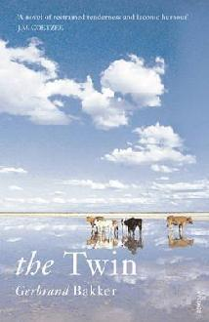This is the story of a man forced to return to the rural Dutch lifestyle of his childhood when his twin brother dies. This debut novel has been shortlisted for and won many literary prizes.

Also available in: eBook

BLAKE, Fanny
A Fresh Start
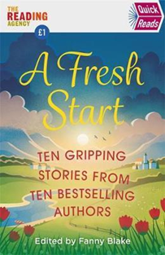
A collection of short stories featuring contributions from Fanny Blake, Louise Candlish, Mike Gayle, Mari Hannah, Sophie Kinsella, Jojo Moyes, Adele Parks, Ian Rankin, Mahsuda Snaith and Keith Stuart.

BRAITHWAITE, OYINKAN
My Sister, the Serial Killer

When Korede's dinner is interrupted one night by a distress call from her sister, Ayoola, she knows what's expected of her: bleach, rubber gloves, nerves of steel and a strong stomach. This'll be the third boyfriend Ayoola's dispatched in, quote, self-defence and the third mess that her lethal little sibling has left Korede to clear away. She should probably go to the police for the good of the menfolk of Nigeria, but she loves her sister and, as they say, family always comes first. Until, that is, Ayoola starts dating the fit doctor where Korede works as a nurse. Korede's long been in love with him, and isn't prepared to see him wind up with a knife in his back: but to save one would mean sacrificing the other.

BRONTE, CHARLOTTE
Villette

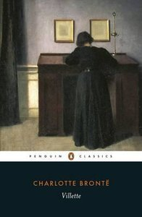
With neither friends nor family, Lucy Snowe sets sail from England to find employment in a girls' boarding school in the small town of Villette. There, she struggles to retain her self-possession in the face of unruly pupils, the hostility of headmistress Madame Beck, and her own complex feelings.

BULGAKOV, MIKHAIL
The Master and Margarita

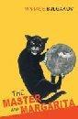
The devil makes a personal appearance in Moscow accompanied by demons. Only the Master, a man devoted to truth, and Margarita, the woman he loves, can resist the devil's onslaught

Also available in: eBook

Burnet, Graeme Macrae,
His Bloody Project

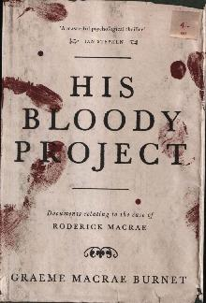
A brutal triple murder in a remote north west Scotland crofting community in 1869 leads to the arrest of a young man by the name of Roderick Macrae. There's no question that Macrae is guilty, but the police and courts must uncover what drove him to murder the local village constable. And who were the other two victims? Ultimately, Macrae's fate hinges on one key question: is he insane? A story ingeniously recounted through the accused's memoir, trial transcripts and newspaper reports. Man Booker Prize Shortlist nominee 2016.
Also available in: CD Audio Book and eBook.

BURNS, ANNA
Milkman

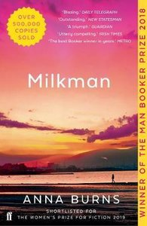
Middle sister, our protagonist, is busy attempting to keep her mother from discovering her maybe-boyfriend and to keep everyone in the dark about her encounter with Milkman. To be interesting is to be noticed and to be noticed is dangerous. Milkman is a tale of gossip and hearsay, silence and deliberate deafness.
Also available in: CD Audio Book, Playaway, Large Print and eBook

BURTON, JESSIE
The Miniaturist

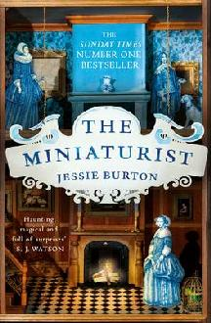
1686. Nella Oortman arrives at a grand house in the wealthiest quarter of Amsterdam. She is about to begin a new life as the wife of illustrious merchant trader Johannes Brandt. Johannes presents her with an extraordinary wedding gift: a cabinet-sized replica of their home. It is to be furnished by an elusive miniaturist, whose tiny creations mirror their real-life counterparts in unexpected ways.
Also available in: CD Audio Book, eBook, eAudiobook and Large Print

BYATT, A.S.
The Children’s Book

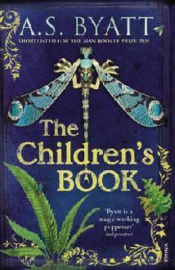
In their rambling house the children play in a story-book world - but their lives, and those of their rich cousins and their friends, the son and daughter of a curator at the new Victoria and Albert Museum, are already inscribed with mystery. Each family carries its own secrets.

BYTHELL, SHAUN
The Diary of a Bookseller

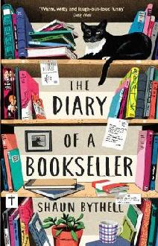
Shaun Bythell owns The Bookshop, Wigtown - Scotland's largest second-hand bookshop. It contains 100,000 books, spread over a mile of shelving, with twisting corridors and roaring fires, and all set in a beautiful, rural town by the edge of the sea. A book-lover's paradise? Well, almost! In these wry and hilarious diaries, Shaun provides an inside look at the trials and tribulations of life in the book trade, from struggles with eccentric customers to wrangles with his own staff.

Also available in eBook

CANNON, JOANNA
Three Things About Elsie

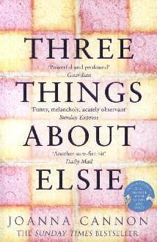
There are three things you should know about Elsie. The first thing is that she's my best friend. The second is that she always knows what to say to make me feel better. And the third thing - might take a little bit more explaining. 84-year-old Florence has fallen in her flat. As she waits to be rescued, Florence wonders if a terrible secret from her past is about to come to light; and, if the charming new resident is who he claims to be, why does he look exactly like a man who died 60 years ago?

Also available in eBook, Playaway and CD Audio Book

CARSON, CLARE
The Dark Isle

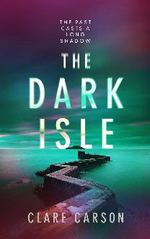
Sam's father was an undercover agent, killed in the line of duty. Now Sam has travelled to Orkney, to piece together the puzzle of his past. What she finds is a tiny island remote enough to shelter someone who doesn't want to be found. An island small enough to keep a secret.

CELESTIN, RAY
The Axeman's Jazz
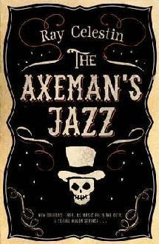
New Orleans, 1919. As serial killer the Axeman stalks the city, three individuals set out to unmask him. Detective Lieutenant Michael Talbot is struggling to find leads. But he has a secret and if he doesn't find himself on the right track fast it could be exposed.

CHASE, EVE
Black Rabbit Hall

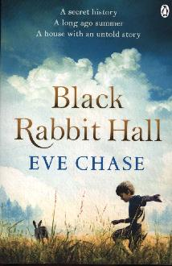
At Black Rabbit Hall nothing much ever happens - time seems to move slower at this idyllic holiday home in Cornwall. Until the worst thing happens and for the Alton children time feels like it's stopped altogether. As they run wild, lost in grief and confusion, an outsider, Caroline Shawcross, and her dark, angry son Lucian enter their lives, changing them forever. In the present day, Lorna Smith is searching for her perfect wedding venue and is inexplicably drawn to the now crumbling Black Rabbit Hall, unaware that her own history is locked up in those derelict walls.

Also available in: Large Print

CHILD, CATRIONA
Trackman
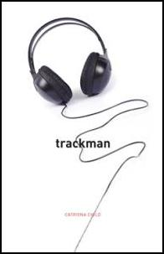

Davie Watts is the Trackman. He knows what song to play to you and he knows exactly when you need to hear it. Set in Edinburgh, this touching, funny and quirky new novel is a truly entertaining read for music lovers everywhere.

Also available in: eBook

CLARK, POLLY
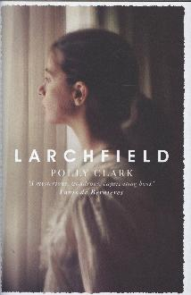
Larchfield
It's early summer when a young poet, Dora Fielding, moves to Helensburgh on the west coast of Scotland and her hopes are first challenged. Newly married, pregnant, she's excited by the prospect of a life that combines family and creativity. She thinks she knows what being a person, a wife, a mother, means. She is soon shown that she is wrong. As the battle begins for her very sense of self, Dora comes to find the realities of small town life suffocating, and, eventually, terrifying; until she finds a way to escape reality altogether.

DE WAAL, KIT
My name is Leon
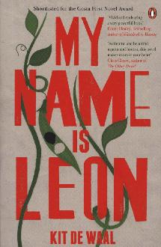
A brother chosen. A brother left behind. And a family where you'd least expect to find one. Leon is nine, and has a perfect baby brother called Jake. They have gone to live with Maureen, who has fuzzy red hair like a halo, and a belly like Father Christmas. But the adults are speaking in low voices, and wearing Pretend faces. They are threatening to give Jake to strangers. Since Jake is white and Leon is not. Evoking a Britain of the early eighties, 'My Name is Leon' is a heart-breaking story of love, identity, and learning to overcome unbearable loss.
Also available in: eBook

DONOVAN, ANNE
Gone are the Leaves
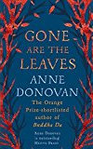
Feilamort is a choir boy in the home of the Laird and his French wife. Deirdre has lived in the castle all her short life, embroidering robes for one of Scotland's finest families. When an awful decision catapults Feilamort and Deirdre head-first into adulthood, the two learn more about Feilamort's forgotten childhood and it becomes clear that someone close is intent on keeping it hidden.

DU MAURIER, DAPHNE
Rebecca
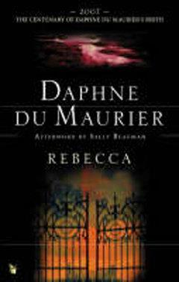A chilling classic about a girl haunted by her own imagination and the ghost of her husband-to-be's former mistress, Rebecca de Winter. Set in Manderley, a beautiful family estate in Cornwall, Rebecca's disturbing presence lingers throughout the house

Also available in: CD Audio Book

ES, BART VAN
The Cut Out Girl
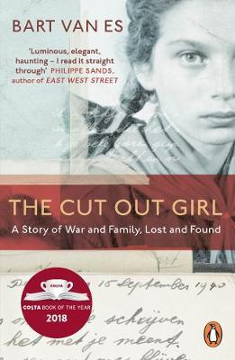
Bart van Es's grandparents took in a girl called Lien in order to hide her from the Nazis. Van Es attempts to trace the story behind Lien coming to be there, achieving a poignant engagement with history comparable to Austerlitz.
Also available in: Large Print and CD Audio Book

FINN, AJ
The Woman in the Window

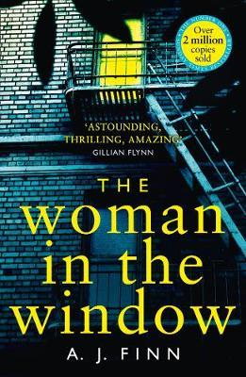
Anna has remained inside her home for the past ten months, experiencing the world beyond entirely through her window. An ostensibly perfect family move in across the street, reminding Anna of a former life, and then drawing her into their darker world after Anna witnesses something no one else would believe.

Also available in: CD Audio Book

FLANAGAN, RICHARD
The Narrow Road to the Deep North

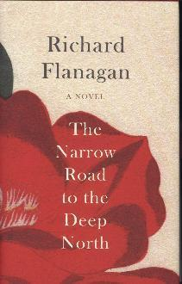
In the despair of a Japanese POW camp on the Burma Death Railway, surgeon Dorrigo Evans is haunted by his love affair with his uncle's wife two years earlier. Struggling to save the men under his command he receives a letter that will change his life forever.

Also available in: eBook and eAudiobook

FULLER, CLAIRE
Swimming Lessons

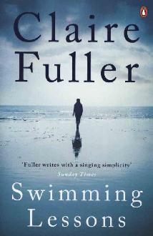
Gil's wife, Ingrid has been missing, presumed drowned, for twelve years. A possible sighting brings their children, Nan and Flora, home. Together they begin to confront the mystery of their mother. Is Ingrid dead? Or did she leave? And do the letters hidden within Gil's books hold the answer to the truth behind his marriage, a truth hidden from everyone including his own children?

GAIMAN, NEIL
The Ocean at the End of the Lane
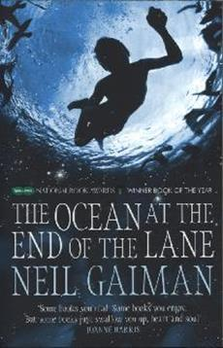
It began for our narrator 40 years ago when the family lodger stole their car and committed suicide in it, stirring up ancient powers best left undisturbed. Dark creatures from beyond the world are on the loose and it will take everything our narrator has just to stay alive.

Gale, Patrick
A Place Called Winter
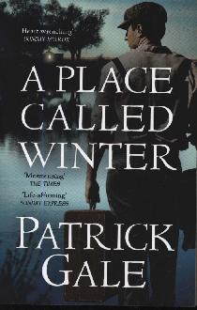
Privileged, shy, conventional Harry Cane is forced to abandon his wife and child at the threat of arrest following the discovery of an illicit affair. He signs up for emigration to the newly colonised Canadian prairies where his remote and unforgiving homestead is a place called Winter.

GENOVA, LISA
Every Note Played

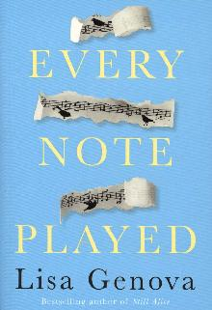
An accomplished concert pianist, Richard has already suffered many losses in his life: the acrimonious divorce from his ex-wife, Karina; the estrangement of his daughter; and now, a devastating diagnosis, ALS. The relentlessly progressive paralysis of ALS begins in the cruellest way possible - in his hands. Karina, who is trapped in her own unfulfilling life, steps in as his reluctant caregiver.

Also available in: eBook

GOMBRICH, E.H.
A Little History of the World
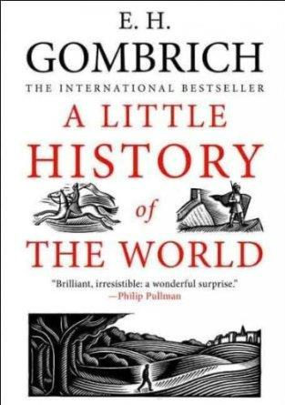
In 40 concise chapters, this tells the story of man from the Stone Age to the atomic bomb. This is a text dominated not by dates and facts, but by the sweep of mankind's experience across the centuries, a guide to humanity's achievements and an acute witness to its frailties.

GRANT, LINDA
We Had It So Good
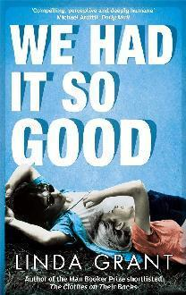

This is the thoughtful and engaging story of a London family from the late sixties to the present. It follows Steven Newman over 40 years, when the events of late middle age and the new century force him and his friends to realise that they've always existed in a fool's paradise.

GROEN, HENDRIK
The Secret Diary of Hendrik Groen, 83 ¼ Years Old

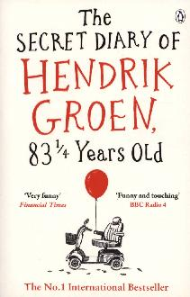
Meet Hendrik Groen. An octogenarian in a care home who has no intention of doing what he's told, or dying quietly. To that end, he creates the Old-But-Not-Dead Club and sets about living his final years with careless abandon. Such anarchism infuriates the care home director but pleases Eefje, the woman who makes Hendrik's frail heart palpitate. If it's never too late to have fun, then can it ever be too late to meet the love of your life?

Also available in CD Audio Book, Large Print and eBook

GUNN, NEIL M

The Silver Darlings
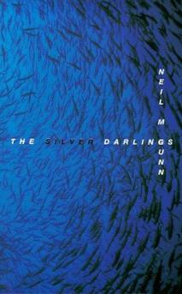
The dawning of the herring fisheries brought with it the hope of escape from the Highland clearances. This is the tale of lives won from a cruel sea and crueller landlords.

GUTERSON, DAVID
East of the Mountains
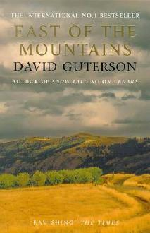

Dr Givens, a heart surgeon, sets out on a journey in his final hours that ends up being a life-enhancing experience.

Also available in: eBook

HAIG, MATT
How to Stop Time

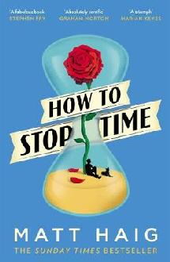
Tom Hazard has a dangerous secret. He may look like an ordinary 41-year-old history teacher, but he's been alive for centuries. From Elizabethan England to Jazz-Age Paris, from New York to the South Seas, Tom has seen it all. As long as he keeps changing his identity he can keep one step ahead of his past - and stay alive. The only thing he must not do is fall in love.

Also available in CD Audio Book, Playaway, eBook and Large Print

HAMID, MOHSIN
Exit West

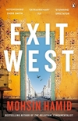
In a city swollen by refugees but still mostly at peace, or at least not yet openly at war, Saeed and Nadia share a cup of coffee, and their story begins. It will be a love story but also a story about war and a world in crisis, about how we live now and how we might live tomorrow. Before too long, the time will come for Nadia and Saeed to leave their homeland. When the streets are no longer useable and all options are exhausted, this young couple will join the great outpouring of those fleeing a collapsing city, hoping against hope, looking for their place in the world.

Hancock, Shelia
Miss Carter’s War
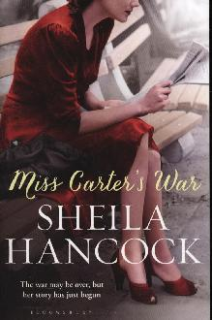
From the peace marches of the fifties and the flowering of the swinging sixties, to the rise of Thatcher and the battle for gay rights, to the spectre of a new war, Sheila Hancock has created a powerful, panoramic portrait of Britain through the life of one very singular woman.
Also available in: eBook

HARDINGE, FRANCES
The Lie Tree
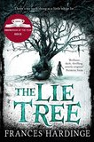
Faith's father has been found dead under mysterious circumstances, and as she searches through his belongings for clues she discovers a strange tree. The tree grows healthy and bears fruit if you whisper a lie to it. The fruit of the tree, when eaten, delivers a hidden truth to the person who consumes it. The girl realizes that she is good at lying, but her tales spiral out of control.

HARPER, JANE
The Dry
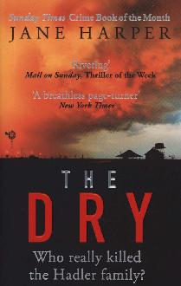
A compulsive, intense and atmospheric debut novel that spent 5 weeks as the No.1 Australian fiction title. Luke Hadler is accused of murdering his wife and son before committing suicide, but as Aaron Falk, policeman and childhood best friend, begins to delve deeper, he questions the truth of his friend's crime

Also available in: CD Audio Book

HEALEY, EMMA
Elizabeth is Missing

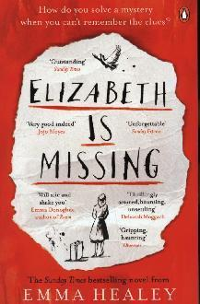
'Elizabeth is missing', reads the note in Maud's pocket in her own handwriting. Lately, Maud's been getting forgetful but she is determined to discover what has happened to her friend Elizabeth and what it has to do with the unsolved disappearance of her sister Sukey just after the war.
Also available in: CD Audio Book, Playaway and eBook

HISLOP, VICTORIA
The Island
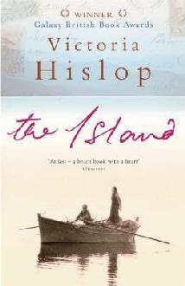
A compelling tale of family ties, with vivid characters and an authentic Cretan background. This dramatic story charts the fate of four generations rent by war, illicit love, passion and leprosy, from the thirties through to the present day.

Also available in: CD Audio Book

HOGG, JAMES
The Private Memoirs and Confessions of a Justified Sinner
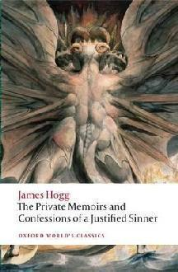

Wringhim believes himself to be one of the elect, predestined for salvation and exempt from moral law, who embarks on a career as a murderer under the influence of a mysterious double.

Honeyman, gail
Eleanor Oliphant is Completely Fine

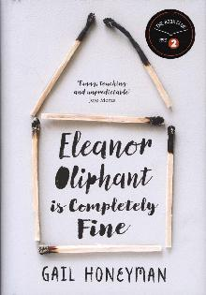
Eleanor Oliphant leads a simple life. She wears the same clothes to work every day, eats the same meal deal for lunch every day and buys the same two bottles of vodka to drink every weekend. Nothing is missing from her carefully timetabled life. Except, sometimes, everything…
Also available in CD Audio Book and eBook

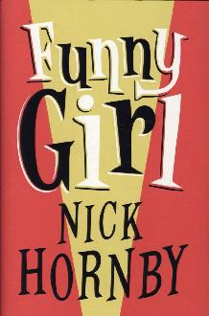
HornbY, Nick
Funny Girl
It’s the swinging sixties, and Sophie Parker escapes the small-town life of her parents in Blackpool and travels to London to follow her dreams and become an actress. But when she lands the TV role of a lifetime, not everything is as it seems.

Also available in: CD Audio Book and eBook

James, Erica
The Dandelion Years
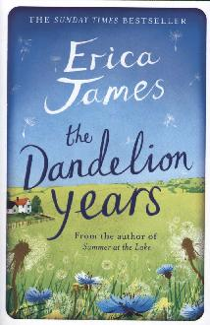
Ashcombe was the most beautiful house Saskia had ever seen as a little girl. Its garden provided a perfect sanctuary to hide from the tragedy which shattered her childhood. Now an adult, Saskia is still living at Ashcombe as a book restorer. When she discovers a carefully concealed notebook Saskia finds herself drawn into a heart-rending tale of wartime love.
Also available in: CD Audio Book, Large Print and Playaway

JONASSON, JONAS
The Hundred-Year-Old Man Who Climbed Out of the Window
and Disappeared
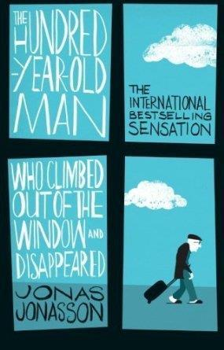

It’s Allan Karlsson’s 100th birthday. Sitting in his room in an old people's home, he is waiting for the party he doesn’t want. Instead he climbs out of the window and makes his getaway. So begins a journey involving criminals, murders, a suitcase full of cash, and incompetent police.

Also available in: eBook

KAWAGUCHI, TOSHIKAZU
Before the Coffee Gets Cold
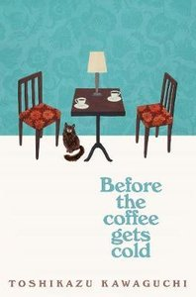
A coffee shop down a Tokyo back alley offers people the chance to travel back in time. Four visitors come at this opportunity with different intentions, but must return from these forays into the past before the coffee gets cold.

Also available in: eBook

KAY, ADAM
This is Going to Hurt

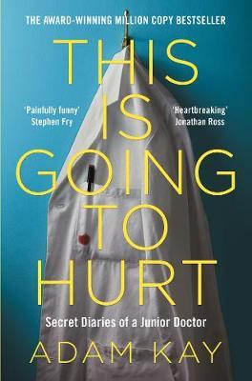
The Sunday Times bestseller. These are the secret diaries of a junior doctor. The often hilarious, at times horrifying and occasionally heartbreaking insight into the life of a junior doctor and the story of why he decided to hang up his stethoscope, considering 97-hour weeks, life and death decisions and earning less than the hospital parking meter.

Also available in: Large Print, CD Audio Book, eBook and eAudiobook
KELLY, HELENA
Jane Austen the Secret Radical
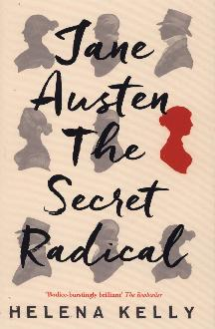
Almost everything we think we know about Jane Austen is wrong. Her novels don't confine themselves to grand houses and they were not written just for readers' enjoyment. She writes about serious subjects and her books are deeply subversive. We just don't read her properly - we haven't been reading her properly for 200 years. 'Jane Austen, The Secret Radical' puts that right. Austen expert Helena Kelly introduces the reader to a passionate woman living in an age of revolution; to a writer who used what was regarded as the lightest of literary genres, the novel, to grapple with the weightiest of subjects.

KELMAN, JAMES
Dirt Road
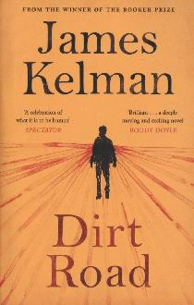
Murdo, a teenager obsessed with music, wishes for a life beyond the constraints of his Scottish island home and dreams of becoming his own man. Tom, battered by loss, stumbles backwards towards the future, terrified of losing his dignity, his control, his son and the last of his family life. Both are in search of something new as they set out on an expedition into the American South. On the road we discover whether the hopes of youth can conquer the fears of age.

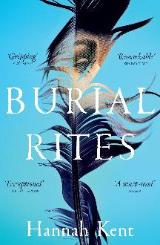
KENT, Hannah
Burial Rites
Iceland – 1829. Agnes Magnúsdøttir is condemned to death for her part in the brutal murder of her lover. Agnes is sent to wait out her final months on the farm of Jøn Jønsson and his family who avoid contact with her. As the year progresses and the hardships of rural life force the household to work side by side, Agnes's story begins to emerge and with it the family's terrible realization that all is not as they had assumed.
Also available in CD Audio Book

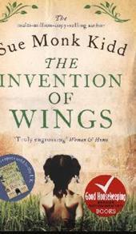
KIDD, SUE MONK
The Invention of Wings
Sarah Grimke is the middle daughter. The one her mother calls difficult and her father calls remarkable. On Sarah's 11th birthday, Hetty is taken from the slave quarters she shares with her mother and presented to Sarah as a gift. Sarah knows what she does next will unleash a world of trouble.

KRAUSS, NICOLE
History of Love
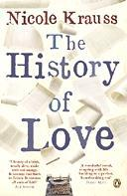
In the Polish village where he was born, Leo fell in love with a young girl called Alma and wrote a book in her honour. These days he is just about surviving life in America. Meanwhile, a young girl, hoping to find a cure for her mother's loneliness, stumbles across a book that changed her mother's life and she goes in search of the author.

LANSENS, LORI
The Girls
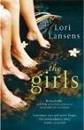
This novel follows the story of conjoined twins, Rose and Ruby. An emotional and immensely readable novel, The Girls is an enchanting blend of the extraordinary and the everyday without any trace of mawkishness.

Also available in: Large Print

LIPTROT, AMY
The Outrun
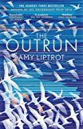
At the age of thirty, Amy Liptrot finds herself washed up back home on Orkney. Standing unstable on the island, she tries to come to terms with the addiction that has swallowed the last decade of her life. As she spends her mornings swimming in the bracingly cold sea, her days tracking Orkney's wildlife, and her nights searching the sky for the Merry Dancers, Amy discovers how the wild can restore life and renew hope.
Also available in: Large Print and eBook

LivelY, Penelope
Ammonites and Leaping Fish
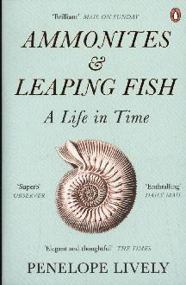
Taking in old age, the context of one's life and times, memory, reading and writing, and the identifying cargo of possessions, this is an elegant, moving and deeply enjoyable memoir by one of our most loved writers.

Also available in: CD Audio Book

LIVINGSTONE, NATALIE
The Mistresses of Cliveden
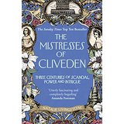
Sex, money, power, politics, and property - this book tells the extraordinary story of how five women used their home to influence British society.
Also available in: CD Audio Book

MCCANN, MARIA
As Meat Loves Salt
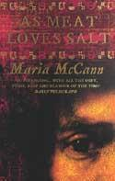
An epic tale of obsession and murder, set during the English Civil War. Tense with anguish, intimacy and shame, it imaginatively re-creates the mentality of a society racked with war and intoxicated by radical new ideas of freedom and change.

Also available in: eBook

MACDONALD, HELEN
H is for Hawk
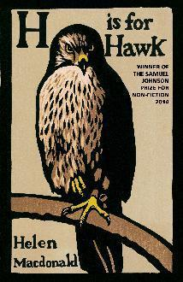
As a child Helen Macdonald was determined to become a falconer. When her father dies and she is knocked sideways by grief, she becomes obsessed with the idea of training her own goshawk. This book is a record of a spiritual journey - an unflinchingly honest account of Macdonald's struggle with grief during the difficult process of the hawk's taming and her own untaming.

Also available in: Large Print and eBook

Macfarlane-Barrow, Magnus
The Shed That Fed a Million Children
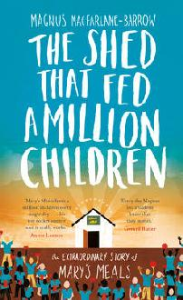
In 1992, after watching a news bulletin about war-torn Bosnia, Magnus MacFarlane-Barrow and his brother agreed to take a week's hiatus from work to help. Magnus retells how a series of miraculous circumstances and an overwhelming display of love from those around him led to the creation of Mary's Meals; an organisation that could hold the key to eradicating child hunger altogether.
Also available in: eBook

MCGREGOR, JON
If Nobody Speaks of Remarkable Things

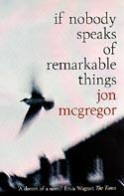
On a street in a town in the North of England, ordinary people are going through the motions of their everyday existence. A young man is in love with a neighbour who does not even know his name. An old couple make their way up to the nearby bus stop. But then a terrible event shatters the quiet of the early summer evening.

Also available in: Large Print

MCGREGOR, JON
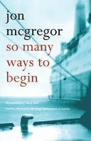
So Many Ways to Begin
David Carter cannot help but wish for more: that his wife Eleanor would be the sparkling girl he once found so irresistible; that his job as a museum curator could live up to the promise it once held. But a few careless words spoken by his mother's friend have left David restless with the knowledge that his life has been constructed around a lie.

MACKINTOSH, CLARE
I Let You Go
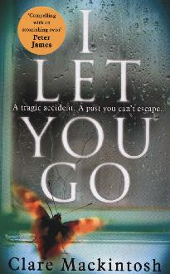
In a split second, Jenna Gray's world descends into a nightmare. Her only hope of moving on is to walk away from everything she knows to start afresh. Desperate to escape, Jenna moves to a remote cottage on the Welsh coast, but she is haunted by her fears, her grief and her memories of a cruel November night that changed her life forever. Slowly, Jenna begins to glimpse the potential for happiness, but her past is about to catch up with her, and the consequences will be devastating.

MACLEAN, SHONA
The Redemption of Alexander Seaton
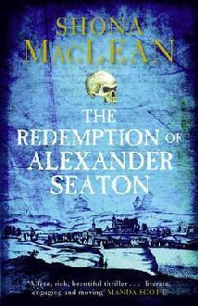

Banff, Scotland in the 1620s: a fallen minister investigates the seemingly motiveless poisoning of a young apothecary's apprentice, a quest that leads to the heart of darkness that lies in the souls of men.

MAGNUSSON, SALLY
Where Memories Go

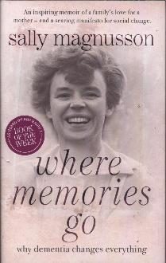
Sally Magnusson cared with her two sisters for her mother, Mamie, during her long struggle with dementia, until her death in 2012. This moving and honest account of losing a loved one day by day to an insidious disease is both deeply personal and a challenging call to arms.

Also available in: Large Print

MAHMOOD, IMRAN
You Don’t Know Me

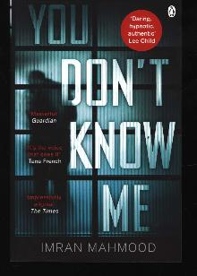
An unnamed defendant stands accused of murder. Just before the Closing Speeches, the young man sacks his lawyer, and decides to give his own defence speech. He tells us that his barrister told him to leave some things out. Sometimes, the truth can be too difficult to explain, or believe. But he thinks that if he's going to go down for life, he might as well go down telling the truth.

Also available in: eBook

MAUGHAM, SOMERSET

The Moon and Sixpence
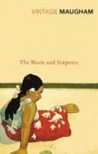
Charles Strickland, a conventional stockbroker, abandons his wife and children for Paris and Tahiti, to live his life as a painter. Whilst his betrayal of family, duty and honour gives him the freedom to achieve greatness, his decision leads to an obsession which carries severe implications.

Moriarty, Liane
Big Little Lies (Also published as Little Lies)
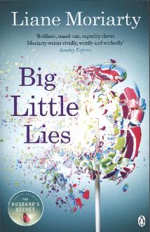
Jane keeps moving in an attempt to escape her past. She finally feels like she belongs in the seaside town of Pirriwee and makes friends in Madeline and Celeste. But then a small incident involving their children causes a rift between them and the other parents of the school. Minor at first but escalating fast, until whispers and rumours become vicious and spiteful. It was always going to end in tears, but no one thought it would end in murder.
Also available in: CD Audio Book and eAudiobook

MORIARTY, LIANE
What Alice Forgot

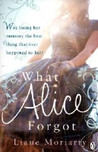
Alice is 29. She is whimsical, optimistic and adores sleep, chocolate, her ramshackle new house and her wonderful husband, Nick. What's more, she's looking forward to the birth of her first baby. But now Alice has fallen and hit her head and everyone's telling her that she's misplaced the last ten years of her life.

Also available in: eBook

MORTON, KATE
The House at Riverton
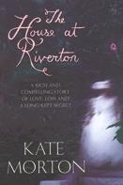
Within these four walls lay a secret that would last a lifetime. A novel about love, loss and long-buried family secrets.

Also available in: Playaway

MOSSE, KATE
The Taxidermist’s Daughter
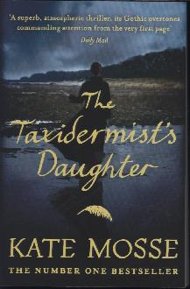
Sussex, 1912. In a churchyard, villagers gather on the night when the ghosts of those who will die in the coming year are thought to be seen. At seventeen, Constantia lives with her father in a decaying house: it is all that is left of Gifford's once world-famous museum of taxidermy. The bell begins to toll and all eyes are fixed on the church. No one sees the gloved hand pick up a flint. As the last notes fade into the dark, a woman lies dead.
Also available in: CD Audio Book

MOYES, JOJO,
Me Before You

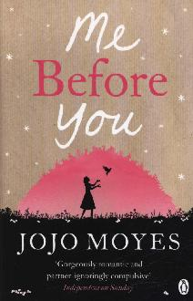
Lou Clark knows lots of things but she doesn't know is she's about to lose her job or that knowing what's coming is what keeps her sane. Will Traynor knows his motorcycle accident took away his desire to live. What Will doesn't know is that Lou is about to burst into his world in a riot of colour.

Also available in: CD Audio Book, Playaway and eBook

Nicholls, David
Us
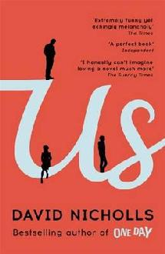
David Nicholls brings to bear all the wit and intelligence that graced 'One Day' in this bittersweet book, which will delight his fans and bring him many new readers. It is a novel about love and family, husbands and wives, and parents and children.
Also available in: Large Print and CD Audio Book

PALACIO, R. J.
Wonder
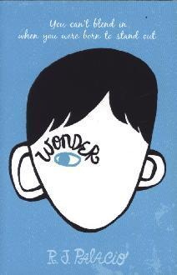
‘Wonder' is the funny, sweet and incredibly moving story of Auggie Pullman. Born with a terrible facial abnormality, this shy, bright ten-year-old has been home-schooled by his parents for his whole life, in an attempt to protect him from the stares and cruelty of the outside world
Also available in: eBook and eAudiobook

PATRICK, PHAEDRA
The Curious Charms of Arthur Pepper
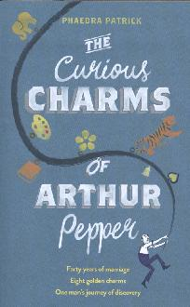
Having been married for over 40 years, 69-year-old Arthur Pepper is mourning the loss of his wife. On the anniversary of her death, he finally musters the courage to go through her possessions, and happens upon a charm bracelet that he has never seen before. What follows is a surprising adventure that takes Arthur from London to Paris and India in an epic quest to find out the truth about his wife’s secret life before they met, a journey that leads him to find healing, self-discovery, and love in the most unexpected of places.

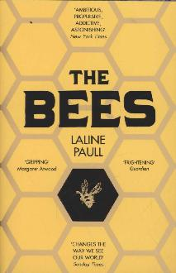
PAULL, LALINE
The Bees
Born into the lowest class of her society, Flora 717 is a sanitation bee, only fit to clean her orchard hive. But Flora is not like other bees. Despite her ugliness she has talents that are not typical of her kin. She finds her way into the Queen’s inner sanctum. But enemies are everywhere. When Flora breaks the most sacred law of all her instinct to serve is overshadowed by an even deeper desire, a fierce love that will lead to the unthinkable.
Also available in: CD Audio Book

PAULSON-ELLIS, MARY
The Other Mrs Walker
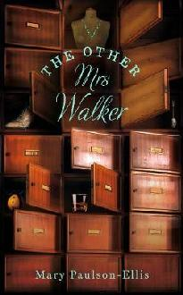
The Other Mrs Walker, a detective story with no detective, is a beguiling debut novel for fans of Kate Atkinson. Upon returning to her hometown, Margaret Penny is tasked with uncovering the astonishing tale of an old woman who died alone.

Also available in: eBook

PETTERSON, PER
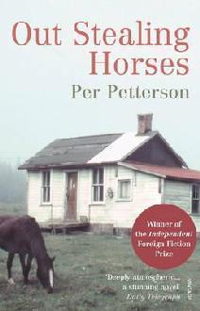
Out Stealing Horses
In 1948, when he is fifteen, Trond spends a summer in the country with his father. The events - the accidental death of a child, his best friend's feelings of guilt and eventual disappearance, his father's decision to leave the family for another woman - will change his life forever.

Also available in: Large Print

ROBERTSON, JAMES
The Testament of Gideon Mack

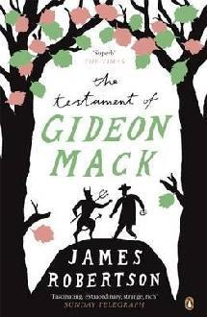
If the devil didn't exist, would man have to invent him? For Gideon Mack, faithless minister, unfaithful husband and troubled soul, the existence of God, let alone the Devil, is no more credible than that of ghosts or fairies. Until the day he falls into a gorge and is rescued by someone who might just be Satan himself.

ROBERTSON, JAMES

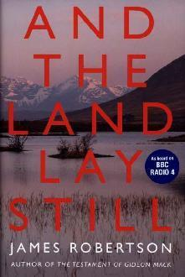
And the Land Lay Still
It is the age of the bomb, the Cold War, Margaret Thatcher and North Sea Oil. As nationalism becomes a credible force in Scotland, a gay photographer, a feminist journalist, a war veteran and a guilt-ridden Conservative MP find their private lives entangled with the ideological conflicts of the times.

Also available in: eBook

ROONEY, SALLY
Normal People

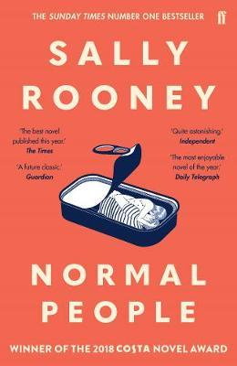
After the critical triumph of Conversations With Friends, the youngest ever recipient of the PFD/}Sunday Times{ Young Writer of the Year Award presents in Normal People a love story taking place between two students at Trinity College in Dublin who are from the same town but essentially different worlds. Themes of domination, legitimacy and privilege are addressed through their story in a tone of alternating compassion and menace.

Also available in: Large Print, CD Audio Book and Playaway

RYAN, DONAL
All We Shall Know

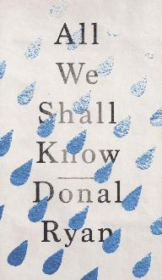
Melody Shee is alone and in trouble. Her husband doesn't take her news too well. She doesn't want to tell her father yet because he's a good man and this could break him. She's trying to stay in the moment, but the future is looming - larger by the day - while the past won't let her go. What she did to Breedie Flynn all those years ago still haunts her. It's a good thing that she meets Mary Crothery when she does. Mary is a young Traveller woman, and she knows more about Melody than she lets on. She might just save Melody's life.

SCHLINK, BERNARD
The Reader
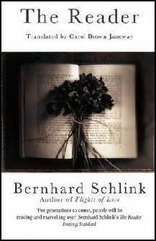
An exceptionally powerful novel exploring the themes of betrayal, guilt and memory against the background of the Holocaust.

SHAFAK, ELIF
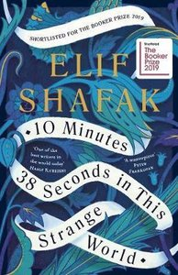
10 Minutes 38 Seconds in this Strange World
For Leila, each minute after her death recalls a sensuous memory: spiced goat stew, sacrificed by her father to celebrate the birth of a yearned-for son; bubbling vats of lemon and sugar to wax women's legs while men are at prayer; the cardamom coffee she shares with a handsome student in the brothel where she works. Each fading memory brings back the friends she made in her bittersweet life - friends who are now desperately trying to find her…
Also available in: ebook

SHAFFER, MARY ANN
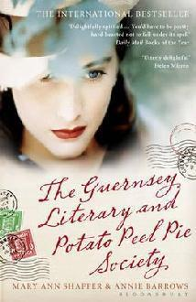
The Guernsey Literary and Potato Peel Pie Society
Set in 1946 and in the form of letters, mainly to and from the central character, Juliet Ashton, a successful writer who becomes, wholly coincidentally, involved with a group of people on Guernsey who lived through the wartime German Occupation.

Also available in: eBook

SHAMSIE, KAMILA
Home Fire

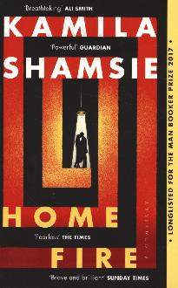
After years spent raising her twin siblings in the wake of their mother's death, Isma is finally studying in America. But she can't stop worrying about her beautiful, headstrong sister back in London - or their brother, who's disappeared in pursuit of his own dream: to prove himself to the dark legacy of the jihadist father he never knew. Then Eamonn enters the sisters' lives. Handsome and privileged, he inhabits a London worlds away from theirs.

Also available in: Large Print, eBook and eAudiobook

SHREVE, ANITA
The Lives of Stella Bain

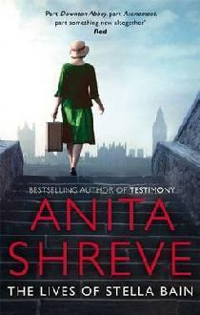
Hauled in a cart to a field hospital in northern France in March 1916, an American woman wakes from unconsciousness to the smell of gas, gangrene, the sounds of men in pain, and an almost complete loss of memory: she knows only that she can drive an ambulance, she can draw, and her name is Stella Bain. A stateless woman in a lawless country, Stella embarks on a journey to reconstruct her life.

Also available in: Large Print, CD Audio Book and Playaway

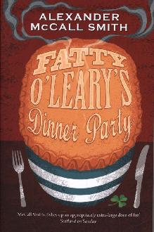
Smith, Alexander McCall
Fatty O’Leary’s Dinner Party
His loving wife Betty plans a trip to Ireland for his 40th birthday and almost immediately things go wrong. The seats in economy class on the plane are too small and Irish bathroom furniture is not as commodious as he'd have liked. And all the time Fatty must put up with the unthinking cruelty of strangers.
Also available in: CD Audio Book, Playaway and eBook

Smith, Ali
Public Library and other stories
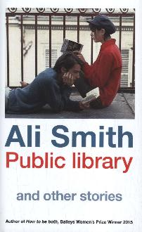
Why are books so very powerful? What do the books we've read over our lives - our own personal libraries - make of us? What does the unravelling of our tradition of public libraries, so hard-won but now in jeopardy, say about us? The stories in Ali Smith's collection are about what we do with books and what they do with us.
Also available in: CD Audio Book, Playaway and eBook

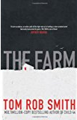
SMITH, TOM ROB
The Farm
Daniel believed that his parents were enjoying a peaceful retirement on a remote farm in Sweden, but with a single phone call, everything changes. His father tells him that his mother has been committed to a mental hospital, but before Daniel can board a plane, his mother calls and tells him that his father is lying. Whom to believe, whom to trust? Daniel must examine the evidence and decide for himself.

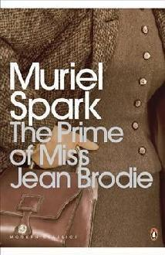
SPARK, MURIEL
The Prime of Miss Jean Brodie
In this classic novel Jean Brodie is a teacher whose unconventional ideas put her at odds with the other members of staff at the Marcia Blaine School in Edinburgh, as she endeavours to shape the lives of the select group of girls who form her "set".

Also available in: CD Audio Book and eBook

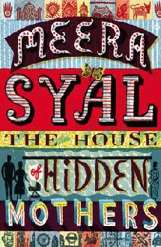
Syal, Meera
The House of Hidden Mothers
Little India, East London: Shyama, aged 44, has fallen for a younger man. They want a child together. Meanwhile, in a rural village in India, young Mala, trapped in an oppressive marriage, dreams of escape. When Shyama and Mala meet, they help each other realise their dreams. But will fate guarantee them both happiness?
Available in: Large Print and eBook

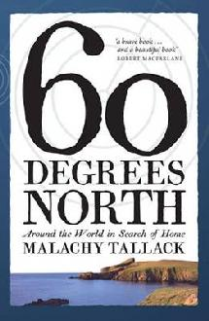
Tallack , Malachy
60 Degrees North
The 60th parallel wraps itself around the lower reaches of Finland, Sweden, and Norway; it crosses the tip of Greenland and of Southcentral Alaska; it cuts the great spaces of Russia and Canada in half. The parallel also passes through Shetland, at the very top of the British Isles. Malachy Tallack explores the places that share this latitude, beginning and ending in Shetland, where he has spent most of his life.

TEARNE, ROMA
Brixton Beach

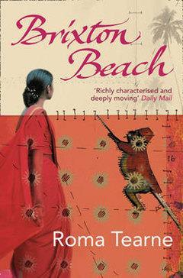
Opening dramatically with the horrors of the 2005 London bombings, this is the profoundly moving story of a country on the brink of civil war and a child's struggle to come to terms with loss.

Also available in: CD Audio Book and eBook

TREMAIN, ROSE
The Road Home
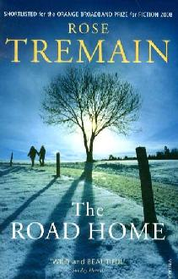
Lev is on his way to Britain to seek work, so that he can send money back to eastern Europe to support his mother and little daughter. He struggles with the mysterious rituals of 'Englishness', and the fashions and fads of the London scene. We see the road Lev travels through his eyes, and we share his dilemmas.
Also available in: Large Print and CD Audio Book

TREMAYNE, S.K
The Ice Twins

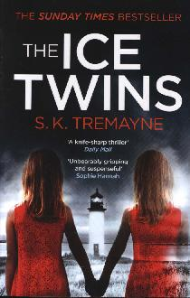
A year after one of their identical twin daughters, dies in an accident, Angus and Sarah Moorcraft move to the tiny Scottish island Angus inherited from his grandmother, hoping to rebuild their shattered lives. But when their surviving daughter, Kirstie, claims they have mistaken her identity - that she, in fact, is Lydia - their world comes crashing down once again. When a violent storm leaves Sarah and her daughter stranded, Sarah finds herself tortured by the past - what really happened on that fateful day one of her daughters died?
Also available in: Large Print

TYLER, ANNE
A Spool of Blue Thread

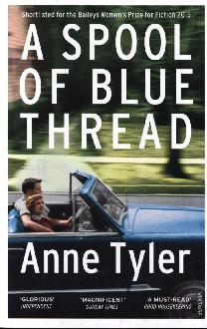
‘It was a beautiful, breezy, yellow-and-green afternoon'. This is the way Abby always begins the story of how she and Red fell in love that day in July 1959. But Abby and Red are getting older, and decisions must be made about how best to look after them and their beloved family home. We spool back through three generations and over all those years we see played out the hopes and fears, the rivalries and tensions of families everywhere - the essential nature of family life.
Also available in: Large Print, CD Audio Book, eBook and eAudiobook

VICKERS, SALLY
The Cleaner of Chartres
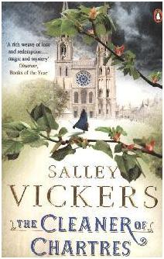
A compelling story of darkness and light, of traumatic loss and second chances, 'The Cleaner of Chartres' tells of the mysterious and elusive Agnes Morel whose little acts of kindness around a rural French cathedral touch the lives of others with consequences both good and ill. But when her tragic past is exposed, Agnes must face up to the truth of her origins.
Also available in: eBook

WARK, KIRSTY

The Legacy of Elizabeth Pringle
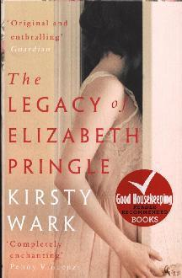
Seemingly on a whim, 95-year-old Elizabeth Pringle bequeaths Holmlea, her beloved house on Arran, to a woman she has never met. Once she arrives at Holmlea she slowly unlocks the mysteries and heartbreaking secrets of Elizabeth Pringle's true legacy, in a multi-generational story of love and belonging
Also available in: CD Audio Book

WATERS, SARAH
The Little Stranger
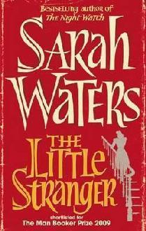

In a post-war summer, a doctor is called to a patient at lonely Hundreds Hall. Home to the Ayres family for over two centuries, the Georgian house, once grand, is now in decline. Its owners - mother, son and daughter - struggle to keep pace. But are they haunted by something more sinister than a dying way of life? Little does Dr Faraday know how closely, and how terrifyingly, their story is about to become entwined with his.

Also available in: CD Audio Book

WATSON, S.J.
Before I Go To Sleep
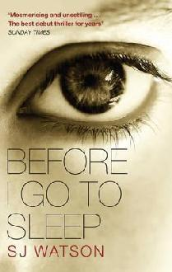

So what if you lost yours every time you went to sleep? Your name, your identity, your past, even the people you love - all forgotten overnight. And the one person you trust may only be telling you half the story.
Welcome to Christine's life.

Also available in: CD Audio Book, Playaway and eBook

WINMAN, SARAH
When God Was a Rabbit

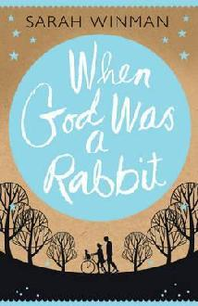
A portrait of childhood and growing up, the loss of innocence, eccentricity and family bonds. Both funny and moving, it's the story of the bond between a brother and sister.
Also available in: Large Print

WODEHOUSE, P.G.
Psmith in the City
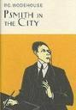

Mike Jackson has to go to a bank to earn his money, instead of going to Varsity. At the bank, by an unusual and artistic coincidence he meets Psmith. Both of them loathe the bank manager for reasons of their own. What follows is plot after plot, from the attempt to gain the friendship of Mr. Rossiter to the offering of their resignation.
Also available in: eBook

YOUNG, KERRY
Pao

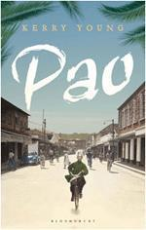
Kingston, Jamaica, 1938. Fourteen-year-old Yang Pao steps off the ship from China with his mother and brother, after his father has died fighting for the revolution. They are to live with Zhang, the 'godfather' of Chinatown. Richly imagined and utterly captivating, Pao is a dazzling tale of race, class and colour, and love and ambition.
Also available in: eBook

