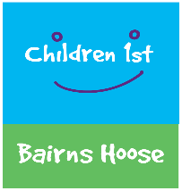
Advocacy Rights and Recovery Support
Bairns Hoose - Aberdeen

Section One
Young person’s name: Click or tap here to enter text.
Young person’s DOB: Click or tap here to enter text.
Young person’s Address: Click or tap here to enter text.
Contact Tel no/email address: Click or tap here to enter text.

Section Two
Parent/Carers name: Click or tap here to enter text.
Parent/Carer Address: Click or tap here to enter text.
Contact Tel no/email address: Click or tap here to enter text.

Section Three
Named Person Details: Click or tap here to enter text.
Named Person Role: Click or tap here to enter text.
Names Person Address: Click or tap here to enter text.
Contact Tel no/email address: Click or tap here to enter text.
Details of any other relevant professionals: Click or tap here to enter text.

Section Four
Brief Family Background:
Click or tap here to enter text.
What is going well?
Click or tap here to enter text.
Do the family have any current supports in place?
Click or tap here to enter text.
What are the families hopes from receiving support from the Advocacy, Rights and Recovery Team?
Click or tap here to enter text.
Is there any support you feel the family need immediately?
Click or tap here to enter text.
Has the child experienced a single incident trauma or multiple traumatic experiences?
Click or tap here to enter text.
What is the status/outcome of the investigation?
Click or tap here to enter text.
Is there any meetings or court dates that we need to be aware of?
Click or tap here to enter text.

